Darley & Summerbridge Community
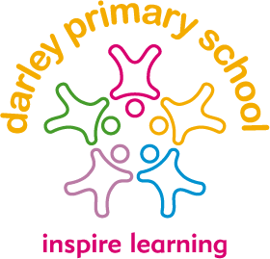
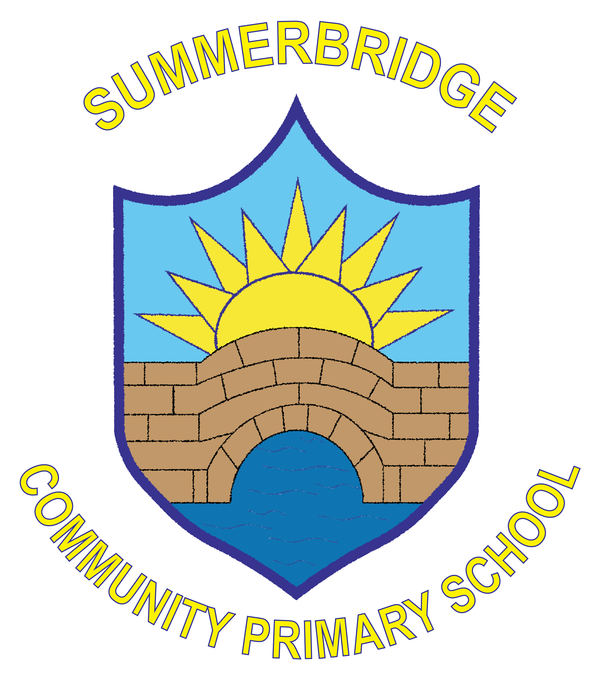
Primary Schools

Remote Learning
(Children with Health needs who cannot attend school) Policy
Rationale

At Darley & Summerbridge Community Primary Schools we think it is essential for all children to have access to a broad, balanced and appropriate curriculum which matches their needs. Our remote learning curriculum is not as enriched as our usual curriculum but does continue to be reflective of the strengths and interests of individual teachers and should be characterised by the whole team of staff where possible. The remote learning curriculum forms a basis from which to promote the aims and values of the school. The remote learning curriculum is taught in a way that is accessible to all pupils. Teachers use a range of resources to plan remote learning (the details of which are below)

Aims and objectives of both schools are:
To ensure that all children are given the opportunity to access remote learning and that no child is unfairly disadvantaged by not being in school.

Organisation and planning
Where possible teachers have planned together across both schools to ensure that all children receive the same level of learning and support. Teachers have planned the remote curriculum so that it continues to demonstrate chronological progression as children progress up through the school with the intention that prior knowledge can act as a platform for future learning.

Teaching and Learning
In our schools we have a system set in place that aims to meet the needs of all pupils. This has taken into account the mixed aged classes, the availability of devices at home, the varying number of children that some parents have, the balance between teachers responding remotely to children at home and working with the children actually in their classes, the intermittent internet accessibility of some of our geographically remote families, the reluctance that some children/parents have to engage with the remote learning and GDPR issues. We recognise that some parents believe that there is too much work being asked of their children, that some believe there is not enough and that some believe that it is just right. Our remote learning seeks to find a compromised balance having taken into account all of the above factors.

Teachers prepare weekly plans that are emailed to parents at the beginning of the week. This plan includes all of the work that they want the children (both remotely and in school) to complete over the course of the week. In addition to this, teachers upload a video of themselves explaining the tasks to ‘Youtube’ at the beginning of the week. This is not a live lesson but a pre-recorded introduction so that parents can access it as many times as they need to.

On Wednesdays, the teachers hold Zoom calls with their classes. This is a mid-week catch up (not a mid-week check-up) to see how the children at home are getting on and if there are any problems that need to be addressed.

On Fridays, the teachers hold another Zoom call with their classes. This is an end of week review where children are encouraged to share their work and any other aspect of their week with their teachers.

At any point during the week, parents are encouraged to contact their child’s class teacher or the headteacher if they require further explanation of the work that is being requested of them.

Resources to support the curriculum

To support the work that teachers send home there are also opportunities for children to access a range of online resources. We use Oak Academy, Reading Plus, White Rose Maths, Literacy Shed, Twinkl, Sumdog, Espresso and Pobble to support the children further.

Subject Leaders
Subject leaders continue to monitor the effectiveness of their subjects through discussion with colleagues, assessment of completed work and through reviewing the quality of remote work available.

Assessment
Assessment of completed work is carried out by teachers remotely. All children have a home learning book for English, Maths and Non-Core Subjects and in this they complete their work. On Friday Zoom catch ups, children are able to share with their teachers the work that they have done and teachers are able to record that the work has been completed.

Children with special needs or children deemed vulnerable
During periods of remote learning, teachers contact vulnerable children separately to ensure that they are safe and well and that they ae accessing the curriculum as best they can. Additional support is offered for these families such as personalised Zoom calls from specific staff should their require it. In addition to this, the headteacher contacts vulnerable families on a regular basis to stay in touch with them.

Monitoring and Evaluation

Governors, LA advisors, the Headteacher and staff are all jointly responsible for contributing to monitoring how the curriculum is delivered and resourced. This is a joint process whereby all information from monitoring enhances and further develop the curriculum to achieve the aims of the school. OFSTED inspections use all monitoring and evaluation information during the inspection process.

Reviewed: January 2021
Next review: January 2022

Approved……………………….

Date……………….

Monitoring

This policy will be kept in the school office

This policy will be reviewed every two years by the Federated Governing Body of both Darley
& Summerbridge Community Primary Schools.

Signed Chair of Governors

Signed Head teacher

Date adopted by Governing Body

