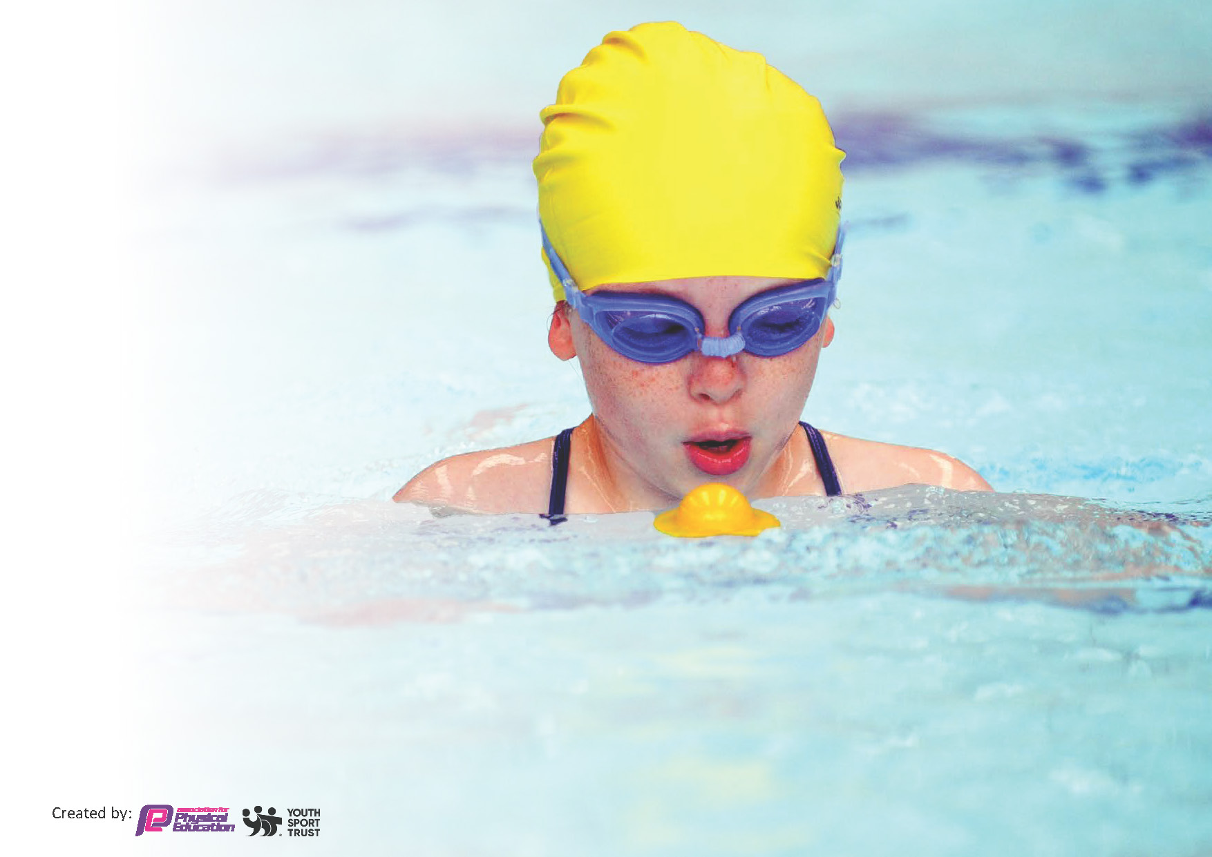
Darley and Summerbridge Sports Funding Statement 2024 - 2025
Review of last year’s spend and key achievements (2024/2025)
by:

Activity/Action | Impact | Comments
Improve resources to ensure that pupils have access to a range of quality equipment so they can experience the broad spectrum of activities over the course of the year | Having a range of quality equipment and resources has meant that pupils have been exposed to better quality lessons as they have benefitted from having the ‘tools’ required to fulfil the expectations of the planned curriculum.  As a result, the enjoyment and involvement of pupils during PE lessons is evident. | None

Key priorities and Planning
This planning template will allow schools to accurately plan their spending.

Action – what are you planning to do | Who does this action impact? | Key indicator to meet | Impacts and how sustainability will be achieved? | Cost linked to the action
CPD for staff by shadowing specialist staff to develop skills and confidence in delivering high quality PE lessons | Primary generalist staff and pupils | Key Indicator 1: Increased confidence, knowledge, and skills of all staff in teaching PE and sport.  Key indicator 2: Increased participation in competitive sport and all pupils taking part in at least 2 hours of PE per week | Primary school staff are more confident to deliver effective PE lessons to develop personal fitness and as a result the percentage of pupil’s attainment and enjoyment in PE has massively increased. | £13,116 used for staff to undertake quality PE CPD through shadowing more experienced colleagues
Contribution towards swimming lessons | Pupils | All pupils are able to access swimming lessons and their attendance at swimming is 100% | Pupils are able to swim 25m at the end of KS2 | £5,200 used to subsidies travel and lessons
Purchase of equipment | Pupils | All pupils are able to take part in PE sessions as we have enough equipment | Pupils contribute and participate in the whole PE curriculum | £546 to replace equipment
Membership of Well Schools Partnership | Pupils | Access to mental health and physical health activities and events | Pupils gain better health | £1,400 membership fee
MSA play activities | Pupils | Pupils take part in structured activities at playtime | Pupils gain better health and mental health | £6,235
 |  |  |  | Total cost: £26,497

Key achievements 2024-2025
This template will be completed at the end of the academic year and will showcase the key achievements schools have made with their Primary PE and sport premium spending.

Activity/Action | Impact | Comments
Key Indicator 1: Increased confidence, knowledge, and skills of all staff in teaching PE and sport. | Staff have developed greater knowledge and confidence in delivering PE lessons. They have participated in lessons in full and have learnt how to support the delivery of this specialist subject. As a result, staff feel much more confident and competent when taking part in and delivering PE lessons. | None
Key indicator 2: Increased participation in competitive sport and all pupils taking part in at least 2 hours of PE per week | All pupils take part in at least 2 hours of quality PE per week. As a result, pupils’ fitness has improved as has their enjoyment of PE sessions. Part of the taught curriculum is the inclusion of competitive sport. This has been a successful aspect of the curriculum as pupils have enjoyed competing against one another throughout the year. | Pupils have not taken part in inter school competitions this year and this is something that we would like to include next year.

Swimming Data
Meeting National Curriculum requirements for swimming and water safety.
Priority should always be given to ensuring that pupils can perform safe self-rescue even if they do not fully meet the first two requirements of the National Curriculum programme of study

Question | Stats: | Further context  Relative to local challenges
What percentage of your current Year 6 cohort can swim competently, confidently and proficiently over a distance of at least 25 metres? | 100% of Year 6 pupils from Darley | 27% - we are struggling to get pool space due to our local pool being a much smaller pool (Nidderdale) than the one we used to use previously (Hydro). We have had to limit the number of lessons that our pupils can attend to just one term which means some pupils have attended fewer swimming lessons than others.
 | 73% of Year 6 pupils from Summerbridge
What percentage of your current Year 6 cohort can use a range of strokes effectively [for example, front crawl, backstroke, and breaststroke]? | 100% of Year 6 pupils from Darley | Of those pupils that can swim 25m, the same numbers can swim the full range of strokes with the exception of butterfly
 | 73% of Year 6 pupils from Summerbridge
What percentage of your current Year 6 cohort are able to perform safe self-rescue in different water-based situations? | 100% of Year 6 pupils from Darley | All pupils were able to perform self-rescue techniques in the pool
 | 100% of Year 6 pupils from Summerbridge

Signed off by:

Head Teacher: | Nicholas Coates
Subject Leader or the individual responsible for the Primary PE and sport premium: | Nicholas Coates
Governor: | Carol White
Date: | 31st July 2025

