

Darley & Summerbridge Primary School Federation

Behaviour Policy

This policy aims to:

• Provide a consistent approach to behaviour management
• Define what we consider to be unacceptable behaviour, including bullying
• Outline how pupils are expected to behave in order to maintain a safe environment in which all pupils can learn and reach their full potential.
• Summarise the roles and responsibilities of different people in the school community with regards to behaviour management
• Outline our system of rewards and sanctions

Promoting Positive Behaviour
At Darley & Summerbridge Primary School Federation, we believe that good behaviour is best promoted through a safe, happy, caring, and inclusive school environment where everyone feels valued, and respected. We are committed to ensuring that all pupils are free from all forms of anti-social behaviour and feel secure in a setting where expectations are clear and consistently upheld by all staff.
We understand that behaviour improves, and children feel safer and happier, when staff apply the behaviour policy consistently and maintain clear routines within the classroom and across the school day. Pupils are more likely to succeed when parents support this approach and work in partnership with school to instil productive learning behaviours.
Low-level disruption in lessons is not accepted, as we believe every child has the right to learn—and every teacher has the right to teach—without interruption. We are committed to fostering a culture in which good behaviour is the norm and high expectations are shared and understood by all members of the school community.
We strongly reject the use of corporal punishment in any form, in line with legal expectations and our safeguarding duties. While we acknowledge that staff have the legal right to use reasonable force when necessary—for example, to prevent personal injury, damage to property, or a criminal offence—this is never used as a disciplinary measure.
To enable this policy to be effective it is important for the adults and children to have agreed standards of what is acceptable behaviour at school.
At Darley and Summerbridge Primary School Federation we define ‘behaviour management’ as:
the promotion of positive behaviour i.e. behaviour which follows the DREAM Code and therefore contributes to a happy, safe and effective learning environment.

We discourage negative behaviour ie behaviour which breaks from the DREAM Code.

DREAMS BEHAVIOUR CODE

Democracy= to treat people fairly
Rule of law = to follow our school rules
Experience individual liberty = to be able to speak and act freely
Acceptance= to work with each other in our school
Mutual respect = to look after each other and our schools

The DREAM Code is used as our reference point when referring to behaviour:

positive behaviour follows some or all of the points in the DREAM Code and therefore is praised and promoted;

negative behaviour is discouraged because it deviates from the DREAM Code in such a way as to undermine our school values.

As such, this policy is as concerned with praise, rewards and encouragement as it is with sanctions.

Stakeholder Responsibilities

Leadership and Management

The Governing Body

The governing body is responsible for monitoring this behaviour policy’s effectiveness and holding the headteacher to account for its implementation.

The Headteacher

The headteacher is responsible for reviewing and approving this behaviour policy in conjunction with the LGB. The headteacher will ensure that the school environment encourages positive behaviour and that staff deal effectively with poor behaviour, and will monitor how staff implement this policy.

Staff are responsible for:

• Implementing the behaviour policy fairly and consistently
• Maintaining consistency in applying this policy throughout the school
• Modelling positive behaviour
• Staying calm when dealing with unacceptable behaviour
• Applying all sanctions fairly and consistently
• Discussing pupil behaviour and discipline regularly at every staff meetings
• Providing a personalised approach to the specific behavioural needs of particular pupils
• Attending appropriate training on behaviour management
• Ensuring the health and safety of the pupils in their care
• Working in partnership parents and carers, keeping them up to date with their child's progress and behaviour at school
• Recording behaviour incidents in the School Behaviour Log
• Maintaining high standards of ethics and behaviour within and outside school and not to undermine fundamental British values and the protected characteristics

The senior leadership team will support staff in responding to behaviour incidents.

Parents are expected to:

• Support their child in adhering to the behaviour expectations of the school

• Support the school’s decisions when implementing the behaviour policy

• Inform the school of any changes in circumstances that may affect their child’s behaviour

• Discuss any behavioural concerns with the class teacher promptly

The following principles inform our approach to behaviour:

• All adults are role models of good behaviour

• All adults notice and celebrate when children behave well

• All adults actively teach children how and why to get along with others

• All adults refer to the same school rules when establishing boundaries

• All adults teach children that most actions are choices and that choices have consequences (this may not be the case for some children with specific learning needs)

• All adults operate a zero-tolerance approach to sexual violence, sexual harassment, and racism.
Children know it is never acceptable and will never be tolerated

• All adults operate a zero-tolerance approach to bullying and cyber bullying children know it is
never acceptable and will never be tolerated

• All adults help children to learn from their mistakes in a spirit of generosity and forgiveness

We have 3 clearly defined school principle: “Keep me safe, make me happy, help me learn” which are designed to encourage children to be display these 3 characteristics at all times.

These school rules are displayed in every classroom. Staff members should discuss
them regularly with their class and children should be able to explain what they mean.

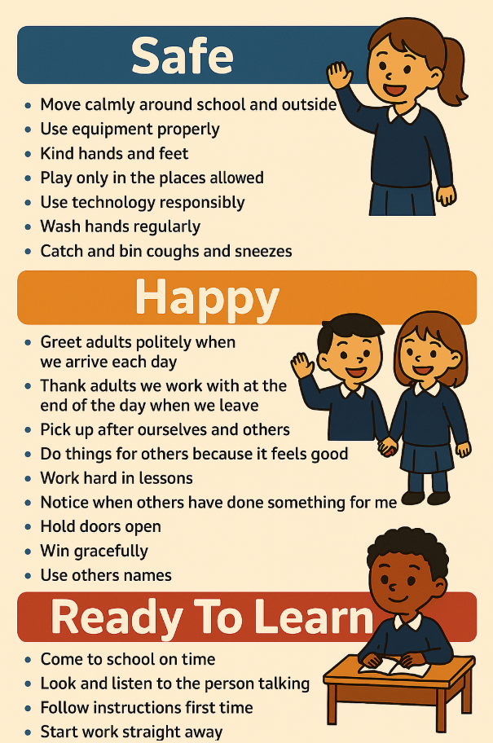

Behaviour Rewards and Sanctions

Our children work in a calm and thoughtful manner. There is a strong family atmosphere in the school and pupils set their own high standards of responsibility and behaviour. Our children are rewarded for effort in line with our school rewards and restorative steps graduated approach as shown in the posters below. Copies of these are displayed in each classroom.
We want children to behave well because it is the right thing to do and not always to get a reward.
However, it is the responsibility of all staff to set and maintain social norms. Children must learn how to behave well, so they need us to be clear and consistent in our expectations, to point out to them what they have done that was good behaviour and to praise them when they have made good choices. It is the responsibility of all staff to maintain our high expectations at all times.
Where sanctions are required, for misbehaviour such as poor attitude in the classroom or outside the graduated restorative steps are used. However, in the case of misbehaviour defined as serious, this will be brought immediately to the attention of the Deputy Headteacher or the Headteacher.
Children at both schools need to adhere to our code of conduct and show a willingness to contribute to the whole school approach of positive praise.
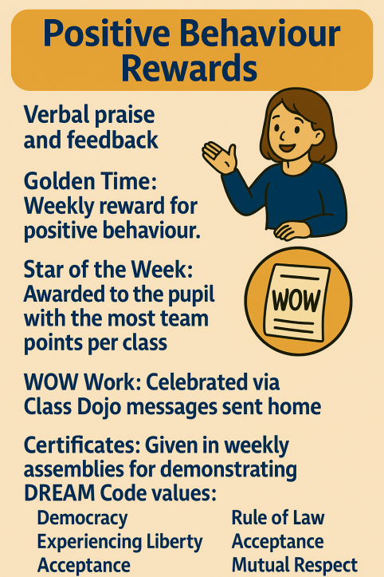
- Verbal praise and feedback.

- Whole school ‘Golden Time’ each week to reward positive behaviour

- ‘Star of The Week’ Award for the pupil with the most team points in each class.

- WOW work messages sent home via Class Dojo to celebrate amazing work.

- Team points are given out using Class Dojo - a whole school reward system, which is used by all staff in all areas of our school.

- Certificates are handed out during weekly assemblies to individuals who perform particularly well in relation to the DREAM Code. These individuals are recognised throughout the whole school and their certificates highlighting their achievements which are on display

- At Summerbridge ‘The William Hardcastle Charity Cup’ is annually awarded to individuals for positive contributions towards school life and the progress cup is annually awarded for progress relative to the child’s starting point.

Classroom Management
If a pupil demonstrates behaviour that is not in accordance with our school’s Core
Values and Golden Rules (and it is deemed a low-level incident), a member of staff
will address this behaviour and help the child to understand why it was unacceptable.

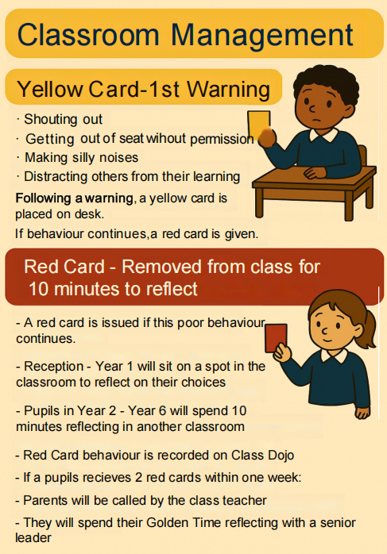

Playtime Management

It is important that our lunchtime supervisors also follow our behaviour policy. Poor behaviour at playtime will be dealt with in the following way:

Verbal Warning
Yellow Card - Sit out on bench for 5 minutes for reflection time
Red Card - Sent inside to see a member of the SLT

Agreed Language

To continue to reinforce our behavioural expectations and remind pupils of their behavior choices, we use the following agreed prompts:

• "Are you making the right choice?"
• "You’re in charge of your choices—and your choices lead to consequences."
• "If you choose to [continue behaviour], you’re also choosing the consequence."
• "Let’s stop and think—what’s the better choice here?"
• "You can make a different choice now."
• "You can join in when you’re ready to make the right choice."
• "That was a great choice—thank you!"
• "Good choices lead to good consequences."

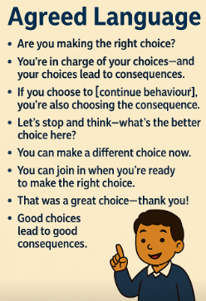
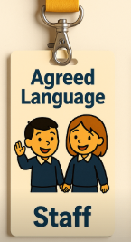

Mobile Phones

Use of mobile phones by pupils:

We recognise that mobile phones and other internet-enabled devices are part of everyday life for many children and that they allow children that walk to and from school unsupervised to get in touch with parents/carers should they need to. However, it is vital that the potential mis-use of phones is acknowledged. Potential negative issues that may arise, could include:

• mobile devices may be lost, stolen or damaged;
• mobile devices can prove a distraction to teaching and learning in school;
• they may provide a means of bullying or intimidating others;
• risks associated with sharing images and with posting digital images on the internet.

Due to these, we have the following arrangements in place:

If it is necessary for a child to bring a mobile phone or other internet-enabled devices to school, for example those children who walk to/from school on their own, these will be kept in a secure place in the school office for the duration of the school day. Mobile phones should not be seen at any time on school site, other than when being put in or taken from the agreed secure place in the classroom. Children MUST hand their phones into their class teacher when they enter the classroom at the start of the day. Phones MUST NOT be left in pockets or school bags during the school day. When children enter the school premises phones MUST be in their pocket or bags and when children are leaving at the end of the school day, having collected their phone from the class teacher, the phone MUST be kept in a pocket or bag and not removed until the child is no longer on the school premises.

Children need to leave their device in the agreed place as soon as they enter the classroom and collect it at the end of the school day. Although it is highly unlikely to happen, Darley and Summerbridge Primary School Federation take no responsibility for any phones lost or damaged at school.

All the above also applies to smart watches and devices that have the ability to send and receive messages and/or take photographs.

Social and Emotional Aspects of Learning (SEAL)

Social and emotional aspects of learning are qualities and skills which help us to manage life and learning effectively. There are five social and emotional aspects of learning:

self-awareness
managing feelings
motivation
empathy
social skills

It is important to develop these aspects of learning as doing so underlies almost every aspect of our lives, including how we behave. The five aspects enable us to learn effectively, get on with others and be responsible citizens.

The Use of ‘Holding to Care’ in School (HtC)

- All staff in both schools have been trained in HtC to be used with pupils but only in very exceptional circumstances.
- We will always seek to defuse any potentially aggressive or dangerous situations without the use of such physical intervention.

This policy does not authorise the use of physical intervention as corporal punishment nor is physical intervention encouraged in any way. There may be circumstances where it is necessary to physically assist pupils – eg after a fall in the playground, a disabled child tackling stairs or the toilet, a child requiring support for a more difficult PE movement, a music teacher demonstrating how to hold an instrument or a member of staff assisting a pupil in adventurous outdoor activities. This policy is not intended to cover such physical contact, and staff will always be aware that any such contact can be misconstrued by pupils and parents.

This policy allows for the holding to care of pupils in disciplinary or dangerous situations. This must not include any form of corporal punishment and should be limited to the force absolutely necessary to prevent injury to the pupil or any other pupils or member of staff, to prevent a pupil causing damage to property or behaving in a manner which is severely disruptive of pupils’ work, or to prevent a pupil committing a crime.

The physical intervention used must be appropriate in the sense that a “reasonable adult” would think it a proportionate or suitable response in the circumstances. It should always be the last
resort and in no circumstances be used in anger or to inflict pain. Any physical intervention used must always be the minimum needed to address the situation.

Any use of physical intervention must always be reported to the Headteacher and where possible, the parents will be notified before the child gets home. If that proves impossible, the parents will be notified as soon as is possible. The name of the pupil and staff concerned, and details of the incident will be logged in school. In the event of a complaint, issues should be raised initially with the Headteacher. If parents do not feel satisfied with the responses, issues should be taken to the Governing Body Complaints
Committee. (refer to the Complaints Procedure)

All responsible adults will be made aware, as part of their induction, of the professional response that is expected in the school in relation to behaviour of pupils.

Exclusions

In very rare cases, exclusion may be considered. This will always follow statutory DfE guidance and involve the headteacher, parents, and governors. In this situation both schools follow the DfE & NYCC guidance on Exclusions which are available online:

https://www.northyorks.gov.uk/exclusion-pupils
https://www.gov.uk/government/publications/school-exclusion
SEND
For a child struggling with their behaviour or who has specific social, emotional and mental health (SEMH) needs the Darley and Summerbridge Federation puts into place a robust plan of support that aims to reduce the need to consider suspension. The focus of these plans is to support the child to be happy, settle and able to learn in school.
Individual Behaviour Planning includes:

• Restorative practice – this is a process which involves the child understanding the
effects of their actions, relecting on their impact on others and making amends.
• Internal Referral Process – a referral form is completed by the class teacher, with
consent from parents which begins a system of plan, do, assess, and review for the
child and enables support from the Learning Mentors, SENCO and Behaviour Mentor
based in school. Parents work closely with school from this point on.
• Behaviour mentor support – to provide support in lessons with a focus on
confidence building and responsibility. Sometimes sessions are 1:1 if more in-depth
learning about behaviour strategies and de-escalation is needed. Daily check-ins are
carried out with all the pupils on this caseload.
• A clear IBP – where behaviour mentor support is given a child will have an IBP to
ensure consistent support for the child and to re-establish boundaries and routines.
• Additional support – some pupils can access other support from staff in school.
• Internal exclusion – for a specified period of time where learning is set by the class
teacher and completed away from the class environment in the leadership office.
• Alternative timetable – linked to the IBP, a child may have a change or reduction in
timetable which allows integration into class where possible.
Definitions
Misbehaviour is defined as:
• Poor attitude in lessons, and at break and lunchtimes
Serious misbehaviour is defined as:
• Repeated breaches of the school rules
• Any form of bullying
• Vandalism
• Theft
• Fighting
• Racist, sexist, homophobic or discriminatory behavior
Bullying / child-on-child abuse is defined as:
The repetitive, intentional harming of one person or group by another person or group, where the
relationship involves an imbalance of power. Bullying is, therefore:
• Deliberately hurtful
• Repeated, often over a period of time
Bullying can include:
• Emotional - Being unfriendly, excluding, tormenting
• Physical - Hitting, kicking, pushing, taking another’s belongings, any use of violence
• Racial - Racial taunts, graffiti, gestures
• Direct or indirect verbal - Name-calling, sarcasm, spreading rumours, teasing
• Homophobic Bullying on the basis of sexuality or for those who may not behave according to gender stereotype
• Cyber-bullying Bullying that takes place online, such as through social networking sites, messaging apps or gaming sites
• Sexual harassment - Sexual activity, sexual language, creating and sharing sexual images, sexist language
Monitoring

This policy will be kept in the school office

This policy will be reviewed annually by the Federated Governing Body of both Darley
& Summerbridge Primary Schools Federation.

Signed Carol White Chair of Governors

Signed Nicholas Coates Head teacher

Date adopted by Governing Body
7th September 2026

Review due
7th September 2027

