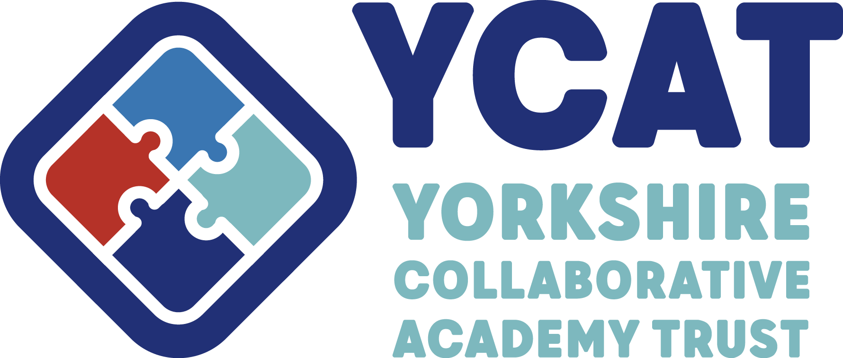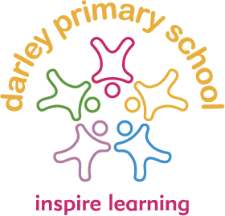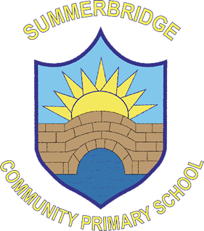

Darley & Summerbridge
Primary School Federation

Curriculum Policy 2024 - 2026
Rationale
At Darley and Summerbridge Primary School Federation we believe it is essential for all children to have access to a broad, balanced and appropriate curriculum which matches their needs. The curriculum forms a basis from which to promote the aims and values of the schools. The curriculum is taught in a way that is accessible to all pupils.

Aims and objectives of the federation is:
• to enable all children to learn and develop their skills to the best of their ability;
• to promote a positive attitude towards learning, so that children enjoy coming to school, and acquire a solid basis for lifelong learning;
• to teach children the basic skills of literacy, numeracy and information technology (IT);
• to enable children to be creative and to develop their own thinking;
• to teach children about their developing world, including how their environment and society have changed over time;
• to help children understand Britain’s cultural heritage;
• to enable children to be positive citizens in society;
• to fulfil all the requirements of the National Curriculum and the Locally Agreed Syllabus for Religious Education 2024 - 2029*;
• to teach children to have an awareness of their own spiritual development, and to understand right from wrong;
• to help children understand the importance of truth and fairness, so that they grow up committed to equal opportunities for all;
• to enable children to have respect for themselves and high self-esteem, and to be able to live and work co-operatively with others.

*Since 1944, all schools have been required to teach RE to all pupils on roll (with the exception that parents have the right to withdraw their children from the subject). Religious Education remains part of the basic curriculum for all pupils.

(If parents would like to withdraw their child from any aspect of the RE curriculum, they should contact their child’s school in writing with their request).

Organisation and planning
We plan our curriculum in three phases. We agree a long-term plan for the key stage. This indicates what topics are to be taught in each half term, and to which groups of children. We review our long-term plan on an annual basis.

Within our medium-term plans, we give clear guidance on the objectives and teaching strategies that we use when teaching each topic. We take our medium-term planning directly from the National Curriculum Programmes of Study but also make use of schemes such as White Rose
Maths and Little Wandle. We use the national curriculum objectives to plan our medium-term planning and use a range of resources to enhance the content.

Our short-term plans are those that our teachers write on a weekly or daily basis. At our federation the curriculum places a greater emphasis on the core and foundation subjects. To ensure pupils are taught the breadth of the curriculum and in order for them to develop a deep understanding of the content subjects are taught from pre-school in a spiral curriculum format. Over the three terms of the academic year, each child has the opportunity to experience the full range of National Curriculum subjects. Our spiral curriculum is based on a two-year rolling programme to ensure that all aspects of learning are covered and to ensure that our mixed aged classes address each year groups’ objectives over the two year period.

Teaching and Learning
The delivery of the curriculum is varied according to the styles of teaching and methods used by all staff in school. We always have a half termly themes which brings together strong cross-curricular links to enhance learning and make the whole process of learning new content interesting, stimulating and meaningful. At Darley and Summerbridge Primary School Federation we think this thematic approach is the preferred way to delivering the curriculum in a small school as it promotes whole school themes throughout the year. The gradual process of building on previous knowledge, skills and understanding of all areas of the curriculum leads to the children making progress as they move through the school. The federation aims to equip all learners with the experiences and skills of computing that will enable them to function in a changing technological world. Pupils will learn the necessary skills to learn a language from KS2.

Resources to support the curriculum
There are many activities which support the curriculum which may involve visits to museums, field studies or places of interest in addition to physical resources such as computer software, apps and books or artefacts. Both schools use members of the community, theatre groups, art and sport specialists and church representatives to support the delivery of the curriculum. Appropriate resources are available in school to enhance teaching. Resources are stored in accessible locations eg hall and stock rooms and other key stage related resources can be found in the classrooms. This method of organising resources allows staff to add or take away materials according to current practice. Staff are responsible for auditing resources to ensure adequate provision is made for all areas. All school computers, iPads and IWs are checked by ICT Services to ensure pupils are safe from external dangers that could be encountered. Both schools maintain a comprehensive school library that children use on a daily basis for fiction and non-fiction books.

Subject Leaders
Subject leaders are involved in supporting colleagues towards ensuring effective teaching and learning throughout both schools. Both schools monitoring programmes allow subject leaders to observe and share good practice. Staff have access to training through the school’s access to Smart Solutions for the curriculum. Both schools also access training and support from outside agencies as well as colleagues in other schools through the Harts Teaching School Alliance

Assessment
Included in the Headteacher’s termly report is an update to inform governors of curriculum developments. Subject leaders are responsible for sharing information and supporting others in both schools. Statutory and non-statutory testing takes place in line with LA and National recommendations. Targets are regularly set to support learning. The children are involved in this process and have targets visable in their classrooms, in their books, homework books and verbally. Targets are set in a variety of ways to support the whole curriculum. We use an internal tracking system to track and monitor pupils’ progress.

Children with special needs
The curriculum in both schools is designed to provide access and opportunity for all children who attend the schools. If we think it necessary to adapt the curriculum to meet the needs of individual children, then we do so only after the parents of the child have been consulted. If a child has a special need, both schools do all it can to meet these individual needs. We comply with the requirements set out in the SEN Code of Practice in providing for children with special needs. If a child displays signs of having special needs, his/her teacher makes an assessment of this need. In most instances the teacher is able to provide resources and educational opportunities which meet the child’s needs within the normal class organisation. If a child’s need is more severe, we consider the child for a statement of special needs, and we involve the appropriate external agencies when making this assessment. We aim to provide additional resources and support for children with special needs. Both schools provide an Individual Educational Plan (IEP) for each of the children who are on the special needs register. This sets out the nature of the special need, and outlines how the schools will aim to address the need. It also sets out targets for improvement, so that we can review and monitor the progress of each child at regular intervals.

Key skills
The following skills have been deemed ‘key skills’ in the revised National Curriculum:
• communication;
• application of number;
• information technology;
• working with others;
• improving own learning and performance;
• problem-solving.
All subject areas contribute to a child’s progress in these skills. Both schools believes that all children need to make good progress in these skill areas in order to develop to their full potential.

Homework
Children benefit from sharing their learning with other adults at home and this can ideally be done through homework. Parents are offered guidance and opportunities to ask questions about tasks set. (Refer to homework policy) Regular newsletters and information are provided to support homework. The oldest pupils have homework tasks and are also given individual passwords to access online sites that they use to enhance their learning.

Extra-curricular provision
There are numerous extra-curricular activities on offer to the children. After-school clubs and events are organised throughout the year by staff. Educational visits to further enhance the curriculum and to allow learning from real experiences are organised and visitors are invited in to share their expertise. Inter Schools sporting events and tournaments are organised in conjunction with the Schools Sports Partnership. The school develops community links and is involved in providing community education. The school website details how the Governments PE Funding is allocated each year and explains the impact it has had.

Monitoring and Evaluation
Governors, Trust colleagues, the Headteacher and staff are all jointly responsible for contributing to monitoring how the curriculum is delivered and resourced. This is a joint process whereby all information from monitoring enhances and further develop the curriculum to achieve the aims of the school.

Monitoring

This policy will be kept in the school office

This policy will be reviewed every two years by the Governing Body of Darley
& Summerbridge Primary Schools Federation.

Approved by:
Headteacher: 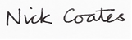
Nick Coates
Chair of Governors: 
Carol White

Adopted by Governing Body 01/12/2021

Reviewed 01/12/2022
Review Due 01/12/2024
Reviewed 08/10/2024 FGB
Next review due 08/10/2026

