
Adopted | February 2025
Frequency of review: | 1 year
To be reviewed by: | Full Board
Date of next review: | February 2027

Trust Safeguarding and Child Protection Policy
2026-27

REVIEW RECORD

Date of review | Reason for review | Date of next review
Feb 2026 | Policy review cycle | Feb 2027

1. Statement of Intent
The purpose of this document is to provide an overarching summary of the aspects of safeguarding and child protection that are common across all schools in YCAT.

Each Academy (school) within YCAT has a Child Protection Policy which is published on their individual website and details their site-specific arrangements. This policy is based on the model North Yorkshire Policy which is produced by the North Yorkshire Safeguarding Board and is updated annually in line with the DFE’s ‘Keeping Children Safe in Education’ document.

A list of trust schools and their key Safeguarding personnel are included in Appendix 1 of this document.

This policy should be read alongside the following documents:
  - Individual trust schools’ Child Protection Policy based on the NYSB policy.
  - Yorkshire Collaborative Academy Trust’s: Managing Allegations Against Adults Working within the Trust Policy
  - DfE Keeping Children Safe in Education – September 2024
  - Working Together to Safeguard Children – December 2023
  - The Children Act 1989 and 2004
  - The Children and Social Work Act 2017
  - The Education Act 2002
  - Human Rights Act 1998
  - Equality Act 2010, including Public Sector Equality Duty
  - Prevent Duty Guidance (2023)

2. The Law and National Framework
The requirements of the Trust and each Academy to safeguard and promote the welfare of all children and young people are embedded in legislation, government, and Local Authority guidance. The Policy, therefore, of the Trust must be, and is, in line with this wider framework.

3. Legal
Appendix 2 outlines the key legal framework and the important difference between prevention and protection which now underpin the work of Safeguarding.

The government guidance ‘Working Together to Safeguard Children – December 2023’ and ‘Keeping Children Safe in Education 2024’ are the essential national safeguarding documents and give practical guidance on implementing legal requirements.

Each Academy should have at least one copy of each which should be accessible to staff. All adults working within the Trust must be issued with their own copy of Part 1 & 5 and Annex A/B of ‘Keeping Children Safe in Education 2024’. Time must be given for staff to read the document.
Senior Leaders working in each Academy are to be issued with ‘Keeping Children Safe in Education 2024’ in its entirety. Time must be given for Leaders to read the document, and they must confirm that they have both read and understood the document.

Every member of staff across YCAT is expected to sign to verify they have read and understood the appropriate parts of KSCIE 2024 on the school’s acknowledgement record sheet. The school’s DSL will be responsible for ensuring these are completed.

4. Local
Local Safeguarding Children Partnerships (LSPs) are made up of senior managers from each main organisation to oversee at a local level the working together arrangements for Safeguarding. Each partnership arrangement will have a unique offer that relates to the community they serve. This body produces local procedures which must be in line with ‘Working Together to Safeguard Children – December 2023’ and which influence each organisation’s own procedures. Each school in YCAT should have a copy of, and show due regard to, their local partnership arrangements. It is also an expectation of the Trust that DSLs will attend update events and training as required by their local partnership arrangements.

The LSPs that currently support YCAT schools are:
- North Yorkshire Safeguarding Children Partnership - https://www.safeguardingchildren.co.uk/

5. Organisational
Each school within YCAT has its own safeguarding arrangements, outlined in the school’s Child Protection Policy. These policies must be reviewed annually, ratified by the Local Governing Body of each academy school, and published on the respective school’s website.

At the trust level, the YCAT Safeguarding and Child Protection Policy must also be reviewed and ratified by the YCAT Board of Trustees annually and published on the YCAT website.

6. Definitions
It is important to see Safeguarding as the “umbrella” term for everything that is done to support children and young people, to keep them safe and promote their welfare. ‘Working Together to Safeguard Children – December 2023’ defines Safeguarding and promoting the welfare of children as:

- providing help and support to meet the needs of children as soon as problems emerge
- protecting children from maltreatment, whether that is within or outside the home, including online
- preventing impairment of children’s mental and physical health or development
- ensuring that children grow up in circumstances consistent with the provision of safe and effective care
- promoting the upbringing of children with their birth parents, or otherwise their family network through a kinship care arrangement, whenever possible and where this is in the best interests of the children
- taking action to enable all children to have the best outcomes in line with the outcomes set out in the Children’s Social Care National Framework

Child protection is part of safeguarding and promoting the welfare of children and is defined in ‘Working Together to Safeguard Children – December 2023’ as activity that is undertaken to protect specific children who are suspected to be suffering, or likely to suffer, significant harm. This includes harm that occurs inside or outside the home, including online.

It can be seen therefore that protection is only one part of Safeguarding and indeed the spirit of the legislation is about promotion of children’s needs and the prevention of harm.

This supports the need for all staff to be able to respond early when they have a concern rather than wait until something is more defined and certain.

The most critical message from the legislation is that ‘the child’s welfare is paramount and is everyone’s responsibility.’

7. Roles and Responsibilities
Everyone has a role to play in ensuring the wellbeing and safety of children, young people, their families, and each other. Below is a brief description of those core responsibilities.

7.1 All Staff

All staff will:

    - Make sure they have undertaken the appropriate training for their role.

    - Take responsibility to report any concerns, no matter what their role including Low Level Concern.
    - Ensure they have a copy of part 1 & part 5 and Annex A/B of Keeping Children Safe in Education 2024 and that they have read and understand it.
    - Be aware of the need to minimise their own vulnerability in not being alone with children or in situations that could render them vulnerable to poor practice and/or allegations against them; and
    - Always be aware of the needs of young people and be vigilant for any possible signs of abuse.
    - Never promise confidentiality
    - Need to be aware of the local early help process and how to make referrals to the local authority

All staff must be aware of systems in school to support safeguarding:
    - YCAT Trust Safeguarding and Child protection Policy, their specific school Child Protection Policy.
    - Behaviour policy which should include measures to prevent bullying, including cyberbullying, prejudice- based and discriminatory bullying
    - Staff code of conduct, managing allegations against staff, reporting low level concerns & whistleblowing
    - Safeguarding response to children who are absent from education, particularly on repeat occasions and/or prolonged periods

All staff should receive appropriate safeguarding and child protection training (including online safety which, amongst other things, includes an understanding of the expectations, applicable roles and responsibilities in relation to filtering and monitoring.)

7.2 The Designated Safeguarding Lead

The Designated Safeguarding Lead (DSL) is a member of each school’s Senior Leadership Team who is responsible for the strategic leadership of Safeguarding.

The DSL is the person to whom staff should pass their concerns and who will ensure a practical and efficient way of dealing with those concerns.

The DSL will:
    - The Designated Safeguarding Lead will adhere to the job description in the school’s Child Protection Policy.
    - Ensure an open and efficient route for staff to bring concerns to them of any sort and to have their concerns taken seriously.
    - Ensure they are appropriately trained to carry out the role.
    - Support staff in ensuring they receive appropriate training.
    - Promote the procedural pathway within the Academy so staff are aware of the way to report concerns.
    - Ensure the school’s procedures are followed and adhered to when referring a child if there are concerns about possible abuse,
    - Offer clear advice and support to staff bringing concerns or needing help.
    - Consider whether concerns referred to him/her need to be referred to Children’s Services Social Care.
    - Offer appropriate feedback as necessary as to the progress of the concern.
    - Maintain written records of concerns about a child/ young person even if there is no need to make an immediate referral and use the school’s systems e.g. CPOMS or Safeguard as necessary.
    - Work together with the Headteacher to ensure the school’s Single Central Register is accurately maintained.
    - Discuss with the Headteacher and/or Trust DSL/CEO any complex concerns.
    - Ensure that all such records are kept confidentially and securely and are separate from pupil records.
    - Ensure that an indication of further record-keeping is marked on the pupil record.
    - Ensure those particularly complex cases are referred without delay, and especially where it involves a child or young person subject to a child protection plan.
    - Follows the LSP’s escalation policy where cases are not progressing in an acceptable manner.
    - Gather, collate, and analyse as appropriate all relevant information for purposes of quality assurance.
    - The designated safeguarding lead should take lead responsibility for safeguarding and child protection, including online safety and understanding the filtering and monitoring systems in place.

7.3 Deputy Designated Safeguarding Lead(s)
    - Each YCAT school will appoint at least one Deputy Designated Safeguarding Lead who will formally provide cover and additional capacity for the DSL.
    - Each Deputy DSL will be trained to the same level as the DSL. In the event of the long-term absence of the DSL, the Headteacher will identify a Deputy DSL to undertake the duties of the DSL listed above.

7.4 The Head of School/Headteacher/Executive Headteacher
The Headteacher in each YCAT school is responsible for ensuring the Designated Safeguarding Lead is effective in their role of providing and accessing high quality services to safeguard and promote the welfare of children and young people accessing provision from their Academy including:

    - Offer day-to-day support and guidance to the DSL as necessary.
    - Oversee the promotion of safeguarding throughout the school, ensuring all staff are appropriately trained and aware of their responsibilities.
    - Ensure cover is provided where necessary in the absence of the DSL.
    - Offer supervision to the DSL in relation to their role and decisions made.
    - Ensure that a senior member of staff is designated as the person in charge of Looked After Children and receives appropriate training.
    - Encourage pupils and parents to inform the school of any concerns.
    - Work with the representative of the Local Governing Body (LGB) to put mechanisms in place to ensure that pupils requiring safeguarding measures are monitored in relation to their situation and progress with their learning.
    - Ensure all recruitment procedures follow safeguarding best practice based on advice from NY HR.
    - Contribute as appropriate to quality assurance processes; and
    - Ensure sufficient allocation of time given to DSLs to undertake the role.
    - Work together with the DSL to ensure the school’s Single Central Register is accurately maintained.

7.5 The School Senior Leadership Team
The School Senior Leadership Team will support the Headteacher to discharge the duties to safeguard children and young people.

The School Senior Leadership Team will:

    - Promote the importance of safeguarding throughout the school.
    - Oversee the effectiveness of safeguarding systems, especially procedures, and review and report any changes that are required.
    - Support the work of the DSL to ensure an effective process for dealing with concerns; and
    - Ensure that the school fulfils its statutory duty to co-operate with other agencies and that the chain of accountability is clear from front line to senior level.

7.6 The Trust
The Trust Executive Team will provide strategic leadership within YCAT for all aspects of safeguarding children and young people.

YCAT has appointed a Lead DSL for the trust who works alongside the CEO to quality assure the safeguarding arrangements in all trust schools.

The Trust Executive Team, with the support of the Lead DSL for the trust will:

    - Ensure that all policies and procedures are reviewed and updated in line with national and local requirements and appropriate changes disseminated to all schools.
    - Ensure that there are systems in place to support the effective management of Safeguarding, especially the role of DSLs, and training for all staff and supervision as appropriate.
    - Ensure that there is someone available to Headteachers who can offer appropriate external advice and support with safeguarding concerns especially when they are complex and/or relate to allegations against staff.
    - Ensure Quality Assurance processes are in place and oversee the information they produce to measure the progress and effectiveness of existing safeguarding frameworks.
    - Produce information to the Trust Board in relation to Safeguarding in order to ensure that the Board can demonstrate that it is discharging its safeguarding obligations appropriately.
    - Ensure that all schools’ DSLs and DDSLs are offered ongoing supervision and support as necessary. This framework ensures a safe child-centred approach to support colleagues and DSLs will collaborate at least once a term through YCAT’s safeguarding network.
    - Maintain a Trust level record of complex safeguarding concerns or incidents involving children or staff that are reported to the CEO/Lead DSL.
    - Ensure that all such records are kept confidentially and securely and are separate from all files that are accessible by the central team.

7.7 The Chief Executive Officer
The Chief Executive Officer, as Accounting Officer, through line management, will provide appropriate challenge and support to the Trust Executive Team to ensure the Trust and the academy schools it is accountable for are taking all opportunities to safeguard and protect the children and young people that access their services.

8 Governance of Safeguarding
YCAT schools must appoint a Safeguarding Named Governor on every Local Governing Body (LGB) whose role it is to:

  - Keep the LGB up to date with statutory safeguarding and child protection guidance, including anything issued locally by your school's safeguarding partners
  - Inform the LGB of whether it needs to make any changes (e.g. in light of new regulations)
  - Provide support and challenge to the school’s Safeguarding Team
  - Understand how safeguarding works in practice in the school
  - To provide strategic leadership of safeguarding

YCAT has appointed a Trustee to take leadership responsibility for the whole Trust’s safeguarding arrangements. However, the full Board of Trustees remains responsible and accountable for safeguarding arrangements across the Trust. Thus, the Board should facilitate a whole Trust approach to Safeguarding, whereby safeguarding and child protection are at the forefront and underpin all relevant aspects of process and policy. Governing bodies and proprietors should ensure all staff undergo safeguarding and child protection training (including online safety which, amongst other things, includes an understanding of the expectations, applicable roles and responsibilities in relation to filtering and monitoring).
The governing body will regularly review the effectiveness of school filters and monitoring systems. They should ensure that the leadership team and relevant staff are:

  - Aware of and understand the systems in place
  - Manage them effectively
  - Know how to escalate concerns when identified.

Trustees and Governors have a specified responsibility for the strategic oversight of Online Safety.

The day-to-day leadership of Safeguarding is delegated to the Trust Executive Team, under the leadership of the CEO who will work with Headteachers and DSLs to ensure that all statutory duties are fulfilled.

The CEO provides regular reports to the Trustee with responsibility for safeguarding, along with the Lead DSL for the Trust and representatives of the School Improvement Leadership Group (SILG). Safeguarding also remains a standing item on all agendas of the full Board and each LGB.

The role of the Safeguarding Trustee, with the support of the full Trust Board, is to provide appropriate challenge and support to the Executive Team to ensure that they are satisfied that the Trust is fulfilling its safeguarding duties identified in the statutory guidance Keeping Children Safe in Education 2024. The Safeguarding Trustee will provide a written assurance report to the full Board on a termly basis. This must include safeguarding assurances regarding the letting of school premises to any organisation or individual within the school lettings agreement (KCSIE).

9. Quality Assurance
Robust safeguarding practices and procedures are key to supporting and safeguarding the children and young people that access services from Yorkshire Collaborative Academy Trust. Effective quality assurance measures are essential in ensuring the practices and procedures are fit for purpose. Three assurance categories are in place to monitor Safeguarding within the Trust (Red, Amber and Green) and schools are placed in the category based on the current rating of their practices. It is important to note that the current grading of each school is reviewed constantly and may be subject to change.

Safeguarding Quality Assurance visits are completed annually in all schools by the CEO and Lead DSL for the Trust. In addition, each school’s SCR is reviewed for compliance in the autumn term, and actions are followed up on.

10. Escalation
Staff need to be aware of those times when concerns may look as though they are not progressing to an outcome or some form of action. This may be indicated by:

  - Difficulty in getting hold of a DSL
  - Staff not being satisfied about the decision of the DSL or Headteacher.
  - Staff aware that a colleague has not passed on a concern.
  - External agencies do not accept a referral from a school when it is felt one is needed.
  - Staff not aware of what has happened to their concern because of a lack of feedback.
It is important that staff do not close down a concern because they feel “stuck” or “they can’t do anymore”. It is important to escalate concerns to DSLs, Headteachers, other senior staff or if necessary, to the Trust Executive Team.
If there are concerns about the work of an external agency, please refer to the escalation policy published by the Local Safeguarding Partnership. The important principle is not to allow a concern to be “closed down” without having received the necessary attention, assessment, and resolution.

If the options above have been explored fully and the concern still isn’t being handled effectively and therefore placing the child or young person at risk, it is important that you continue to escalate your concerns by contacting the Safeguarding Trustee, Lizzie Oliver: the CEO, Jo Robinson or LA Safeguarding Escalation Team or by contacting the NSPCC Whistleblowing Advice Line on 0800 028 0285.

11. Low Level Concerns/Managing Allegations against Adults Working with Children
The Trust takes very seriously allegations against members of staff and acknowledges that if concerns are not addressed as early as possible, they can create unsafe working environments and leave staff and children increasingly vulnerable.

The Trust has a ‘Managing Allegations against Staff’ Policy which should be followed in all cases where concerns are identified in relation to an adult working within the Trust, whose conduct affects/could affect pupil(s) welfare or may result in a potential safeguarding issue.

11.1 Low Level Concerns
Creating a culture in which all concerns about adults are shared responsibly and with the right person, recorded and dealt with appropriately, is critical. If implemented correctly, this should:

    - enable schools and colleges to identify inappropriate, problematic or concerning behaviour early
    - minimise the risk of abuse, and
    - ensure that adults working in or on behalf of the school or college are clear about professional boundaries and act within these boundaries, and in accordance with the ethos and values of the institution.

11.2 What is a low-level concern?
The term ‘low-level’ concern does not mean that it is insignificant, it means that the behaviour towards a child does not meet the threshold set out in KCSIE. A low-level concern is any concern – no matter how small, and even if no more than causing a sense of unease or a ‘nagging doubt’ - that an adult working in or on behalf of the school or college may have acted in a way that: is inconsistent with the staff code of conduct, including inappropriate conduct outside of work; and does not meet the allegations threshold or is otherwise not considered serious enough to consider a referral to the LADO.

Concerns about colleagues in the context of pupil welfare and Safeguarding may arise in several ways. Examples of behaviour that could require reporting a low-level concern could include, but are not limited to:

    - poor attitude or practice that potentially impacts on the general wellbeing of children that need addressing
    - aspects of poor practice witnessed by others
    - staff speaking or behaving against the ethos of the Trust
    - non-compliance with Trust’s policies and procedures relating to Safeguarding
    - being repeatedly over-friendly with children
    - engaging with a child on a one-to-one basis in a secluded area or behind a closed door

More specifically, allegations may be made against an adult working within the Trust by a child or colleague in relation to abuse. All the above will be seen as reportable matters and discussions must take place without delay with the Headteacher.

11.3 Reporting low-level concerns
Where a low-level concern has been identified, this must be reported as soon as possible to the Headteacher/Trust DSL. However, it is never too late to share a low-level concern if this has not already happened. The reporting and logging mechanism for this is using the form in appendix 5 which is also in YCAT’s Staff Code of Conduct document.

Where the Headteacher/Trust DSL is not available, the information will be reported to the designated safeguarding lead (or deputy), i.e., the most senior member of SLT acting in this role.

Where the low-level concern has been reported to the Designated Safeguarding Lead, they will inform the Headteacher of the details as soon as possible and ask the ‘reporter’ to complete the form in appendix 5

Low-level concerns are not limited to YCAT employees but also includes supply staff, volunteers, contractors and any other adult who has direct or indirect contact with children. In this circumstance the normal reporting procedure applies of filling in the YCAT Concern form and reporting to the DSL/Headteacher.

11.4 Reporting Staff Welfare Concerns
It is important to safeguard staff welfare and wellbeing. All staff have a duty to support each other. Where a staff member has a concern about a colleague's wellbeing or welfare, they must report this as soon as possible to the Headteacher/Wellbeing Lead.

Speaking directly with the Headteacher, Line manager, CEO or Lead DSL for the trust is always the best option.

Where a staff member wants to report any concern to the Headteacher and remain anonymous then their anonymity needs to be respected.

11.5 Allegations that may meet the harms threshold
However, certain allegations in relation to staff must be immediately reported by the Headteacher to the Trust Designated Officer (CEO), who is the statutory lead for dealing with and advising about such issues, specifically where a member of staff has:

    - behaved in a way that has harmed a child or may have harmed a child and/or.
    - possibly committed a criminal offence against or related to a child and/or.
    - behaved towards a child or children in a way that indicates he or she may pose a risk of harm to children; and/or
    - behaved or may have behaved in a way that indicates they may not be suitable to work with children.

The last bullet point above includes behaviour that may have happened outside of school or college, that might make an individual unsuitable to work with children, this is known as transferable risk.

Internal decisions in such cases should not be finalised without the advice of the Trust Designated Officer. The reasons why staff may not wish to report their colleagues must be understood. It would not be unusual for people to know and believe that practice is not acceptable but feel unable to respond because of the fear:

    - They might have the concerns wrong.
    - For their own job and prospects if they report another colleague.
    - Of isolation by other staff.
    - About what might happen to the member of staff in the long term.

It is particularly difficult if staff members are also close friends and/or partners in a relationship. It must be recognised that a child’s welfare remains paramount at all times, and it can be extremely easy to lose sight of the impact on others of being on the receiving end of unacceptable and sometimes illegal behaviour.

Issues about attitude and poor practice may be dealt with internally and as part of the member of staff’s development and competence. However, if such concerns are persistent and any plan with that member of staff has not affected change, advice should be sought, and appropriate people included in the decision-making process.

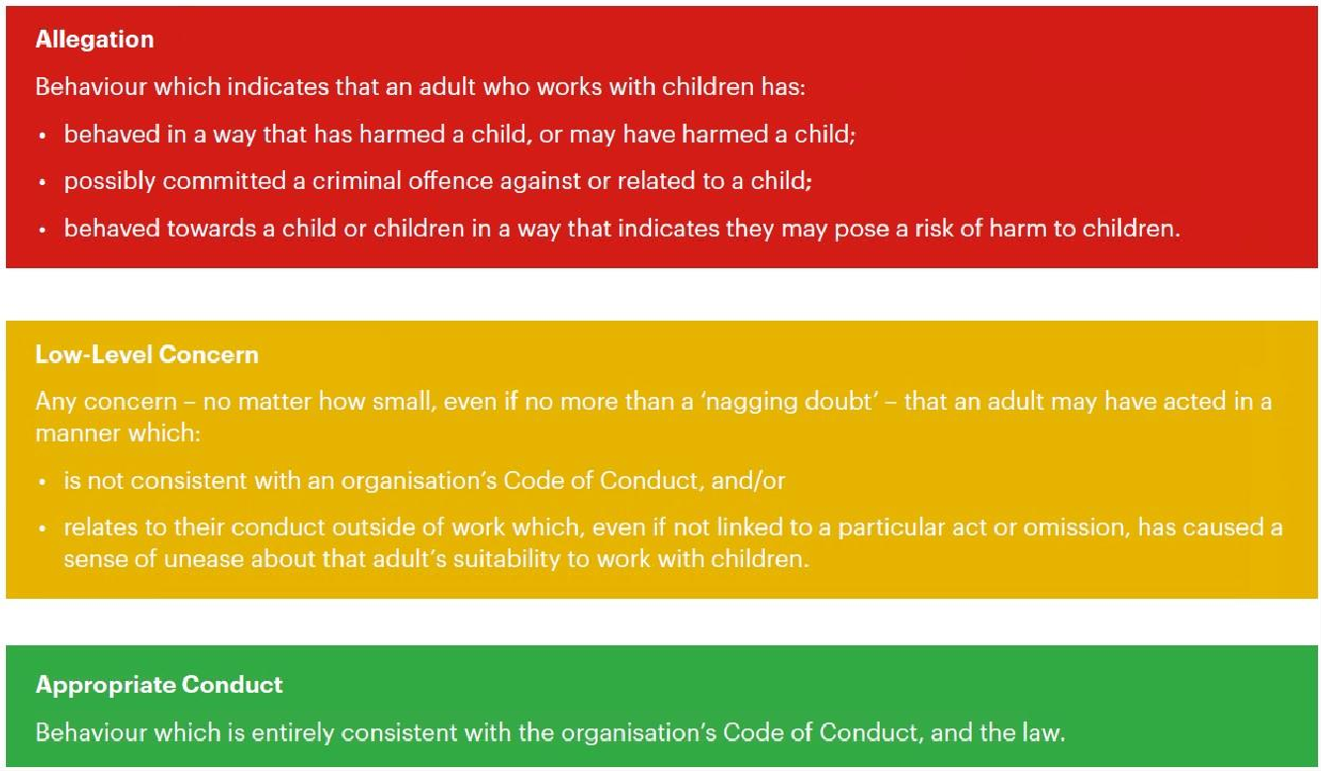
11.6 Clarity around Allegation vs Low-Level Concern vs Appropriate Conduct

11.7 Recording low-level concerns
All low-level concerns should be recorded in writing using appendix 5 and will be held in confidential school and/or trust files. The record should include details of the concern, the context in which the concern arose, and action taken. The name of the individual sharing their concerns should also be noted, if the individual wishes to remain anonymous then that should be respected as far as reasonably possible.

Schools and colleges can decide where these records are kept, but they must be kept confidential, held securely, and comply with the Data Protection Act 2018 and the UK General Data Protection Regulation (UK GDPR) (see paragraph 109 for more information).

Records should be reviewed so that potential patterns of concerning, problematic or inappropriate behaviour can be identified. Where a pattern of such behaviour is identified, the school or college should decide on a course of action, either through its disciplinary procedures or where a pattern of behaviour moves from a concern to meeting the harms threshold, in which case it should be referred to the LADO. Consideration should also be given to whether there are wider cultural issues within the school or college that enabled the behaviour to occur and where appropriate policies could be revised, or extra training delivered to minimise the risk of it happening again.

Information and records will be held in line with the YCAT Data Retention Policy.

11.8 Process to follow when a Low-Level Concern is raised:
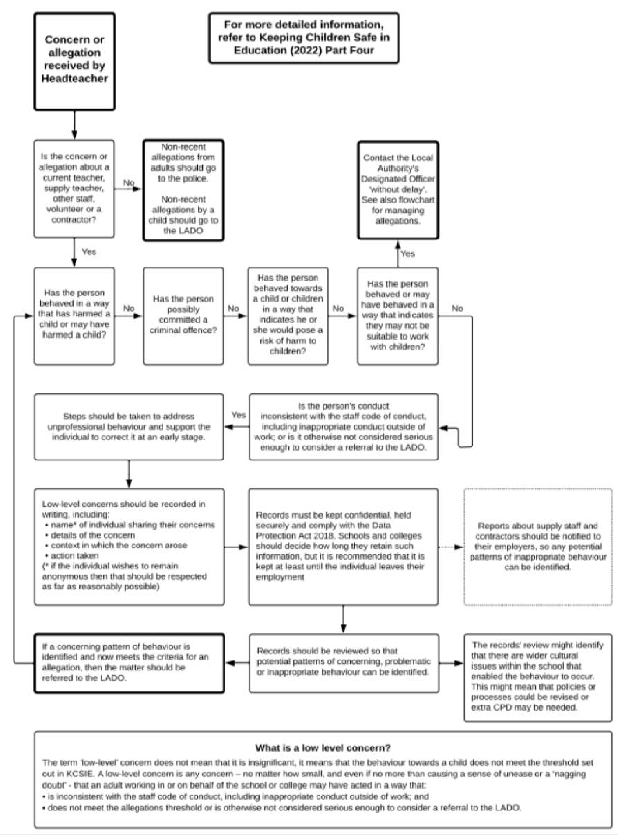

Appendix 1 – List of named personnel with designated responsibility for Child protection for YCAT and each school as of 1 September 2024

Executive Safeguarding Lead | Designated Safeguarding Lead  (DSL) | Prevent Lead | Safeguarding Trustee | Chair of Trust Board
Jo Robinson  CEO | Nick Coates  HT Darley Primary School | Jo Robinson  CEO | Lizzie Oliver | Jenny Baynes
jrobinson@ycatschools.co.uk  07710 759471 | ncoates.darley@yactschools.co.uk  01423 780234 | jrobinson@ycatschools.co.uk  07710 759471 | loliver.trustee@ycatschools.co.uk  01423 709600 | jbaynes.trustee@ycatschools.co.uk  01423 709600

School | DSL  DDSL | Email/Tel No. for DSL | Designated Safeguarding Governor | Chair of Governors
ASKWITH | DSL: Lisa Longford  DDSL: Elaine Nayler | Llongford.askwith@ycatschools.co.uk  01943 462896 | Don Parker | Nigel Muttick
BILTON GRANGE | DSL: Helen Ashby-Smith  DDSL: Sian James | Hashby-smith.bilton@ycatschools.co.uk  01423 502375 | Gill Clarke | Gill Clarke
BRADLEYS’ BOTH | DSL: Emma Fawcett  DDSL: Barry Rogers | bradley@ycatschools.co.uk  01535 633116 | Alison Hitchen | Becky Stapleton
CONONLEY | DSL: Catherine Pickles  DDSL: Jaki Fraser  DDSL: Lucy Holmes | cpickles.cononley@ycatschools.co.uk  01535 633040 | Katie Mason | Katie Mason
DARLEY | DSL: Nick Coates  DDSL: Andy Haworth | ncoates.darley@ycatschools.co.uk  01423 780234 | Katie Milne | Carol White
HAWES | DSL: Andrea Caygill  DDSL: Elaine Nayler | acaygill.hawes@ycatschools.co.uk  01969 667308 | Mike Hirst | Abbie Rhodes
LEYBURN | DSL: Sarah Salonga  DDSL: Sarah Beveridge | Ssalonga.leyburn@ycatschools.co.uk  01969 623187 | Leigh Carmichael | tbc
LOTHERSDALE | DSL: Lucy Bateman  DDSL: Melanie Tyson | lbateman.lothersdale@ycatschools.co.uk  01535 632510 | Alan  Weekes | Anna Chapman
OSMOTHERLEY | DSL: Jane Bamber  DDSL: Linda Pickard | Jbamber.osmotherley@yactschools.co.uk  01609 883329 | Alison Holland | Ryan Fraser-Standloft
SUMMERBRIDGE | DSL: Nick Coates | ncoates.darley@ycatschools.co.uk  01423 780446 | Katie Milne | Carol White
THRESHFIELD | DSL: Sarah Harper  DDSL: Bethany Alexander | Sharper.threshfield@ycatschools.co.uk  01756 752348 | Ian Green | Brettle Roberts

Appendix 2 – Legal Powers and Duties

The Children Act 1989 and 2004 outline the powers and duties to safeguard and promote the welfare of children. The key sections are described below.

Children Act 2004
Section 10 requires each Local Authority to make arrangements to promote co-operation between the authority, each of the authority’s relevant partners and such other persons or bodies working with children in the Local Authority’s area as the authority considers appropriate. The arrangements are to be made with a view to improving the wellbeing of children in the authority’s area, which includes protection from harm or neglect alongside other outcomes.

Section 11 places duties on a range of organisations and individuals to ensure their functions, and any services that they contract out to others, are discharged with regard to the need to safeguard and promote the welfare of children.

This is a particularly important section for the Trust and all the Academies in understanding its need to co-operate with Children’s Services Social Care in fulfilling this duty to safeguard and protect.

The Children and Social Work Act 2017
The Children Act 2004, as amended by the Children and Social Work Act 2017, strengthens this already important relationship by placing new duties on key agencies in a local area. Specifically, the police, clinical commissioning groups and the local authority are under a duty to work together, and with other partners locally, to safeguard and promote the welfare of all children in their area.

Education Act 2002
Section 175 places a duty on Local Authorities in relation to their education functions, the governing bodies of maintained schools and the governing bodies of further education institutions (which include sixth-form colleges) to exercise their functions with a view to Safeguarding and promoting the welfare of children who are either pupils at a school or who are pupils under 18 years of age attending further education institutions. The same duty applies to independent schools (which include Academies/free schools) by virtue of regulations made under section 157 of this Act.

Children Act 1989
The Children Act 1989 places a duty on Local Authorities to promote and safeguard the welfare of children in need in their area.

Section 17(1) of the Children Act 1989 states that it shall be the general duty of every Local Authority:
- to safeguard and promote the welfare of children within their area who are in need; and
- so far as is consistent with that duty, to promote the upbringing of such children by their families, by providing a range and level of services appropriate to those children’s needs.

Section 17(10) states that a child shall be taken to be in need if:

- the child is unlikely to achieve or maintain, or to have the opportunity of achieving or maintaining, a reasonable standard of health or development without the provision of services by a Local Authority under Part III of the Children Act 1989.

- the child’s health or development is likely to be significantly impaired, or further impaired, without the provision of such services; or
- the child is disabled.

Under section 17, Local Authorities have responsibility for determining what services should be provided to a child in need. This does not necessarily require Local Authorities themselves to be the provider of such services.

Section 47(1) of the Children Act 1989 states that:

Where a Local Authority:
- are informed that a child who lives, or is found, in their area
  - is the subject of an emergency protection order, or
  - is in police protection; and
- have reasonable cause to suspect that a child who lives, or is found, in their area is suffering, or is likely to suffer, significant harm: the Authority shall make, or cause to be made, such enquires as they consider necessary to enable them to decide whether they should take any action to safeguard and promote the child’s welfare.

Section 53 of the Children Act 2004 amends both section 17 and section 47 of the Children Act 1989, to require in each case that before determining what services to provide or what action to take, the Local Authority shall, so far as is reasonably practicable and consistent with the child’s welfare:
- ascertain the child’s wishes and feelings regarding the provision of those services or the action to be taken; and
- give due consideration (with regard to the child’s age and understanding) to such wishes and feelings of the child as they have been able to ascertain.

Police Protection Powers Under section 46 of the Children Act 1989, where a police officer has reasonable cause to believe that a child could otherwise be likely to suffer significant harm, the officer may:

- remove the child to suitable accommodation; or
- take reasonable steps to ensure that the child’s removal from any hospital, or other place in which the child is then being accommodated is prevented.

No child may be kept in police protection for more than 72 hours.

Appendix 3 – Induction Training

 | All school staff | YCAT Central Team | Governors and Trustees
ESSENTIAL TRAINING | KCSIE Parts 1 & 5  every year | KCSIE Parts 1 & 5  every year | KCSIE Full Document  every year
ESSENTIAL TRAINING | KCSIE 2024 Update Course for Staff  every year | KCSIE 2024 Update Course for Staff  every year | KCSIE 2024 Update Course for Governors and Managers.  NGA update course  every year
ESSENTIAL TRAINING | Child Protection Training  every 2 years | Child Protection Training  every 2 years | Child Protection Training  every 2 years
ESSENTIAL TRAINING | PREVENT  every 2 years | PREVENT  every 2 years | PREVENT  every 2 years
ESSENTIAL TRAINING | Cyber Security Training for school staff  every year | Cyber Security Training for school staff  every year | Cyber Security Training for safeguarding  every year
ESSENTIAL TRAINING | Safer Recruitment  (at least 2 members)  every 3 years | Safer Recruitment  (at least 2 members)  every 3 years | Safer Recruitment  (at least 2 members)  every 3 years
Other Role-dependent training | Child on Child  Sexual Violence,  Domestic Abuse,  Safer Recruitment  FGM  Domestic Abuse  County Lines  Serious Violence & Knife Crime  Operation Encompass

Appendix 4 – Training Log

YCAT schools are required to keep an up-to-date record of staff training, preferably saved within the same location as their Single Central Record document.

For example:

Name | KCSIE Parts 1 & 5 | KCSIE 2024 Update Course for Staff | NYSCB Safe-guarding children | Child Protection Training | PREVENT | Operation Encompass | Cyber Security Training | Safer Recruitment | GDPR training

See Single Central Record for Darley and Summerbridge Training details – request from the School Office /Headteacher.

Appendix 5 – Low-Level Concerns Reporting Form



Low Level Concern Form

This form can be used to share any concern with the Designated Senior Manager/Headteacher, no matter how small or seemingly insignificant, even if no more than causing a sense of unease or a ‘nagging doubt’ – that an adult may have acted in a way that is inconsistent with the Schools’ Code of Conduct [including inappropriate conduct outside of work] and/or in a way that on first glance does not appear to meet the allegation, ‘harm’ threshold.
A concise record is required, including brief context in which the low-level concern arose, plus details which are chronological, precise and as accurate as possible, of any such concern and /or relevant incident[s]. [Continue on separate sheets as necessary]. The form should be signed, times and dated.

Details of CONCERN:
Name of Staff member:  Signed: | Role:  Time and Date:

Received by:

At [time]: Date:
WAS THE STAFF MEMBER SPOKEN TO? [Good practice will require a response].
NO ☐ - Give a brief but valid reason/explanation for not.

YES ☐ - Please complete detail below - STAFF MEMBER’S RESPONSE TO CONCERN:

ACTION TAKEN:

Was advice/guidance sought from the LADO and or Human Resources? Yes: ☐ No: ☐

Signed: | Dated:

