
Darley and Summerbridge Primary School Federation
Website Cookie Policy
Date: May 2026
Review date: May 2028
Website Cookie Privacy Notice
This privacy notice has been written to inform you about how Darley and Summerbridge Primary School Federation as part of Yorkshire Collaborative Academy Trust (YCAT) processes your personal data when you visit our website, and in particular our use of cookies and web analytics.
Who are we?
Darley and Summerbridge Primary School Federation is a data controller as defined by the UK GDPR. This means that we determine the purposes for which your personal data is processed and the manner of the processing. We will only collect and use your personal data in ways that are compliant with data protection legislation.
Darley and Summerbridge Primary School Federation has, through the Trust appointed Veritau Ltd as its Data Protection Officer (DPO). The role of the DPO is to monitor our compliance with the UK GDPR and the Data Protection Act 2018 and advise on data protection issues. If you would like to discuss this privacy notice or our use of your data, please contact Veritau or Kerry Young (kyoung@ycatschools.co.uk).
Veritau’s contact details are:
Web analytics
Web analytics is the collection and analysis of the data generated when people visit and use a website. This helps the website owner know such things as the number of visitors to various parts of the website, the time they spend on the website and if
they return to the website. Various tools are used to produce web analytics, such as Google Analytics, which uses a set of cookies to collect data.
This website uses the following web analytics:
Identify here what web analytics are in use throughout your website. Your IT provider/web developer will be able to answer this.
What are cookies?
A cookie is a small file of text that may be saved on the memory or storage of your electronic device (computer, phone, or tablet etc) when you visit a website. Cookies are used to improve the way the website works and can be used to remember the information you’ve provided so that you don’t have to re-enter it whenever you visit a new page.
Two types of cookies are typically used:
Session cookies – these are temporary and are removed when you close your browser or leave a website. These are used to remember visitors as they move from page to page on a website and are typically used to store your basket when using online shopping.
Persistent cookies – these remain on your device for much longer, even after you close the browser or restart the device. They remain until you remove them or they expire, which can be up to 12 months. They are typically used to store information such as your name, language preferences or login information.
What do we use cookies for?
We use cookies so that:
• We can distinguish you from other users of our website and provide a good experience.
• We can remember the information you’ve provided us with while on our website, so you don’t have to keep re-entering the information whenever you visit a new page.
• We can look at how you use our website so that we can improve it for other users.
We do not use cookies to:
• Monitor your usage of other websites (privacy intrusive cookies).
• Collect any personal information about you (without your express permission).
• Collect any sensitive information.
• Pass data to any advertising networks.
• Pass personal data to third parties.
Consent for cookies
When you first visit our website using a new browser we will provide you with a cookies permission banner, seeking your consent to the use of certain cookies.
Not all cookies require consent. Those which are required for the operation of the website, known as ‘strictly necessary’ cookies do not require consent. Without these cookies the website cannot work as designed.
Other types of cookies do require consent. These include:
· Functionality cookies, which are used to improve the usability of the website; Analytical or performance cookies, which are used to help us improve the website; and
· Advertising or marketing cookies, which are used to target advertising on a website.
You can change your cookie preferences at any time through our cookie banner, but please be aware that opting out of cookies may affect your user experience on our website.
What is our lawful basis for processing your information?
Under the UK GDPR, it is essential to have a lawful basis when processing personal information. We normally rely on the following lawful bases:
· Article 6(1)(a) - consent
· Article 6(1)(f) – legitimate interest
We only rely on legitimate interests when we are using your data in ways you would reasonably expect.
Copyright
All information on this website, including but not limited to graphics, design, text, and images, is subject to the copyright of the school or a third party that has given permission for the school to use the material. The school grants permissions to electronically copy, print to hard copy, or transfer such material, so long as it is for school business only.
Disclaimer and external links
The school makes every effort to ensure the content on this website is correct and factual. The school accepts no liability for any inconvenience or loss caused by reliance on any information contained on this website.
The school makes every effort to ensure links to external websites are secure. The school accepts no liability for the privacy practices of those external websites.
Accessibility
We are committed to providing a website that is accessible to the widest possible audience, regardless of technology or ability. This website has been designed to be as accessible as possible while still visually interesting. To do this we have considered a variety of features which are summarised below. Click on the links to see information on the particular accessibility issues.
Alternative Style
Images and Alt Tags
Browser Compatibility
Coding Standards
Consistent Navigation
Contact
What rights do you have over your data?
Under the UK GDPR, individuals have the following rights in relation to the processing of their personal data:
· to be informed about how we process your personal data. This notice fulfils this obligation.
· to request a copy of the personal data we hold about you.
· to request that your personal data is amended if inaccurate or incomplete.
· to request that your personal data is erased where there is no compelling reason for its continued processing.
· to request that the processing of your personal data is restricted.
· to object to your personal data being processed.
If you have any concerns about the way we have handled your personal data or would like any further information, then please contact our DPO using the details provided above.
If we cannot resolve your concerns then you may also complain to the Information Commissioner’s Office, which is the UK’s data protection regulator. Their contact details are below:
Phone: 0303 123 1113 or via their live chat. Opening hours are Monday to Friday between 9am and 5pm (excluding bank holidays). You can also report, enquire, register and raise complaints with the ICO using their web form on Contact us | ICO.
Changes to this notice
We reserve the right to change this privacy notice at any time. We will normally notify you of changes that affect you. However, please check regularly to ensure you have the latest version.
This policy was last reviewed: May 2026
Approved by:
Headteacher: 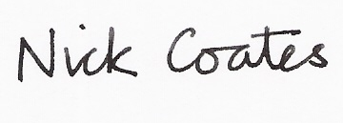 Date: May 2026
Nick Coates
Chair of Governors: 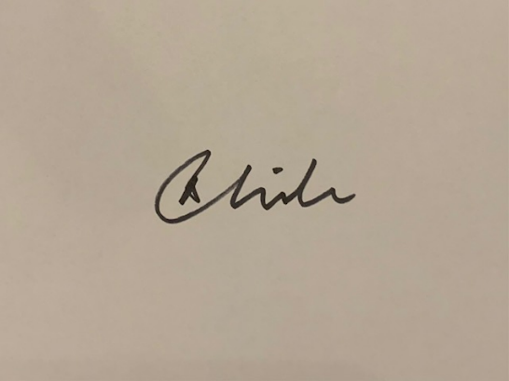 Date: May 2026
Carol White

